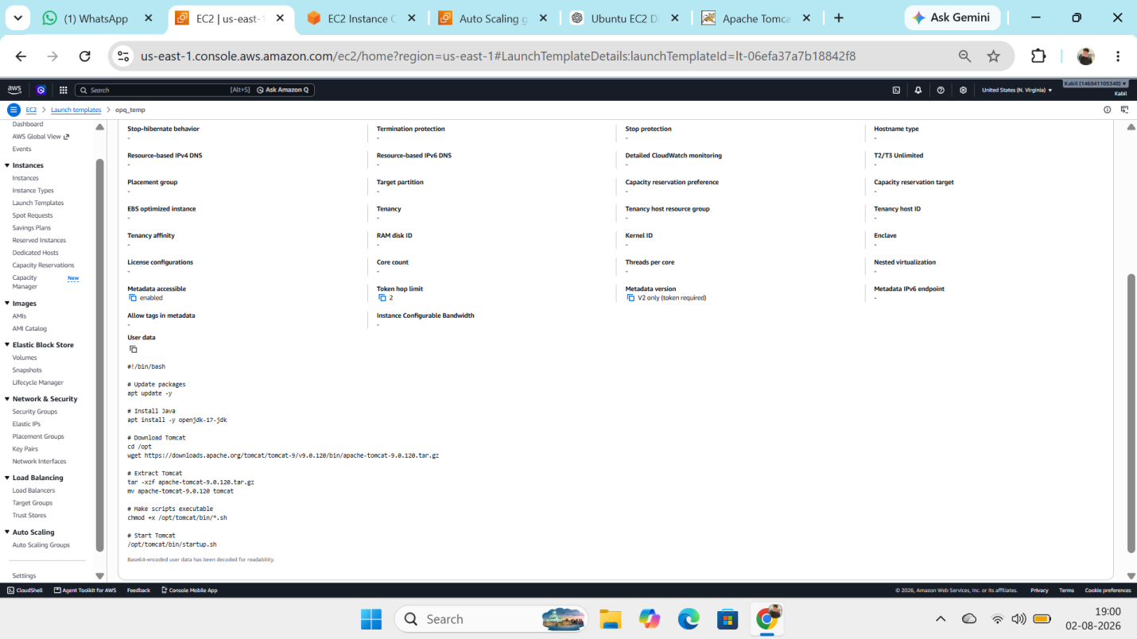
Step : 1 Create an new launch temple with containg the user data for run the script java install, tomcat install and run the tomcat service and Launched the ASG autoscaling groups and given the stress to CPU.
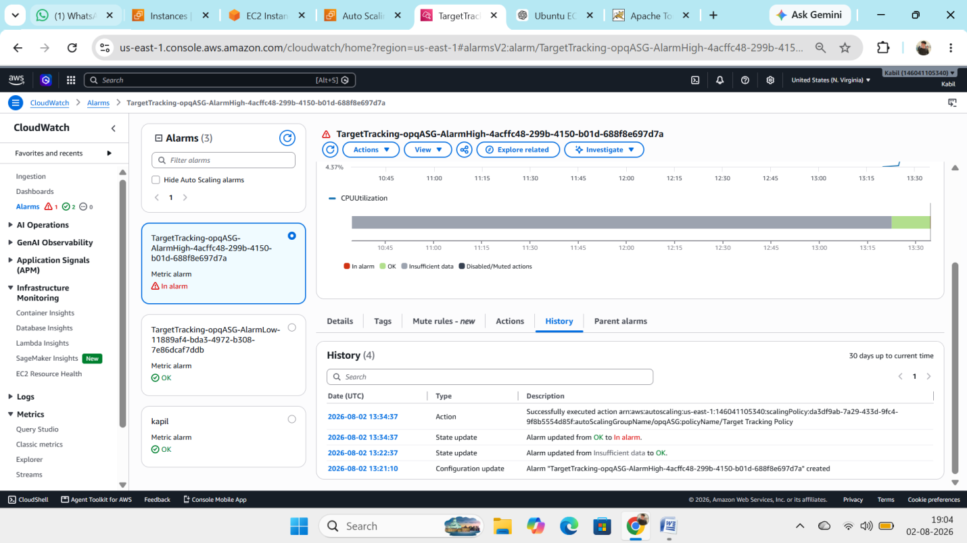
Step 2: CPU exceed 50% alarm triggered and ASG create new ec2 instance with help of launch template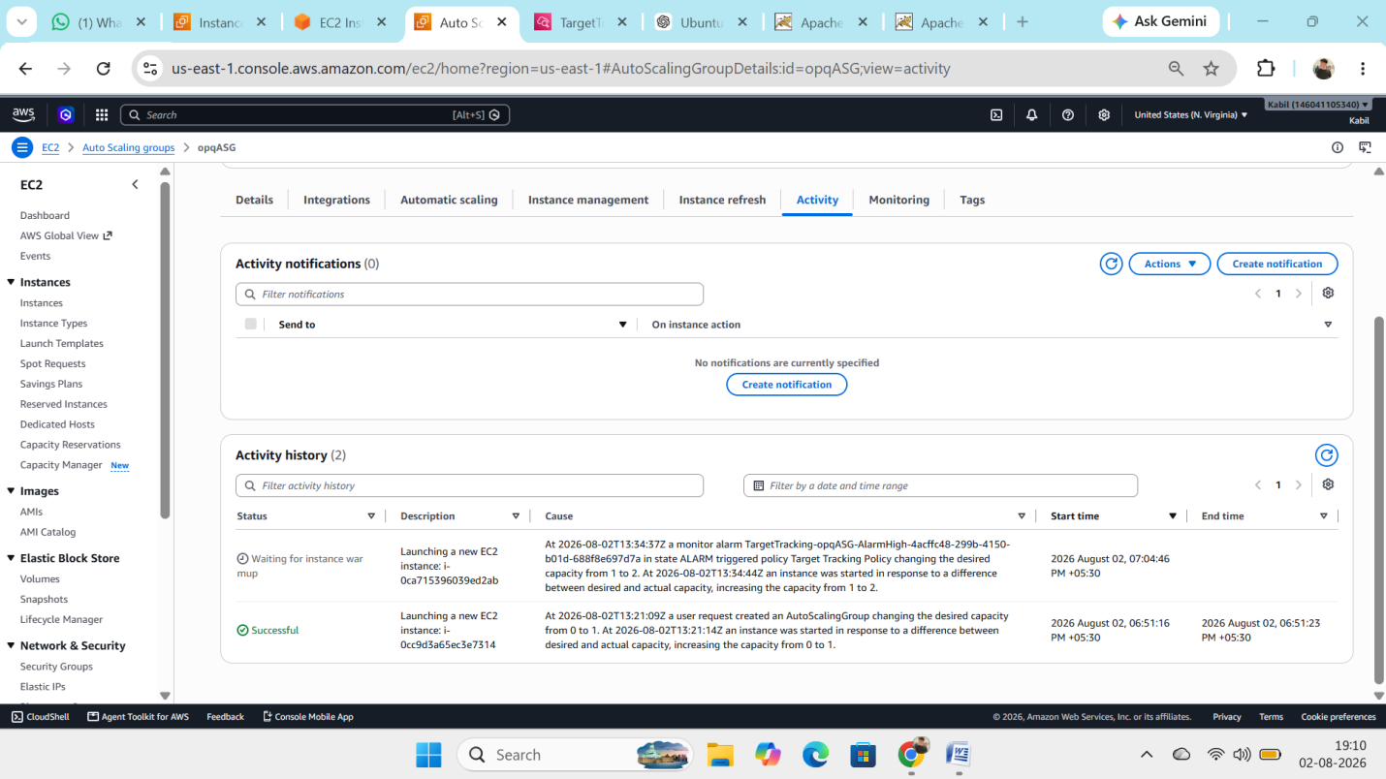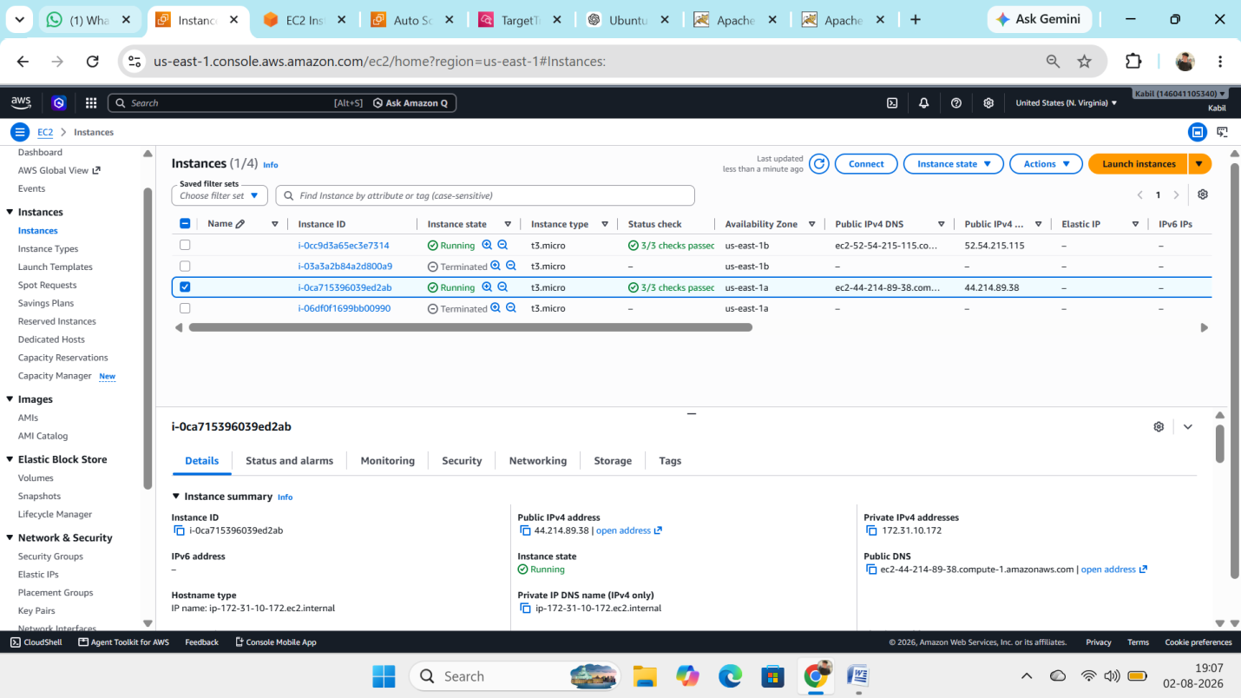
Step 3: new EC2 is created
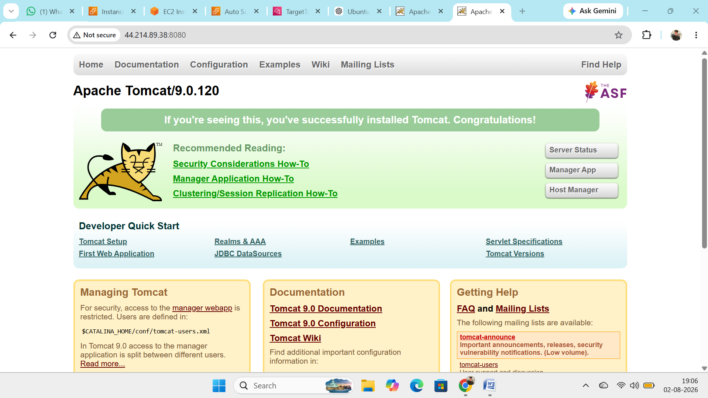
EC2 1 tomcat service.
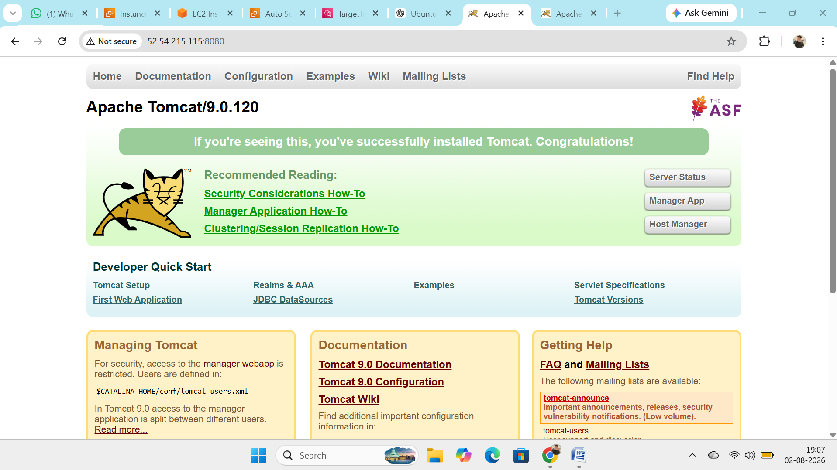
EC2 2 tomcat service.

